LIBRARY MANAGEMENT SYSTEM
A Desktop-Based Application using C# and MySQL
Bachelor of Science in Information Technology

ABSTRACT
The Library Management System is a desktop-based application developed using C# Windows Forms and MySQL. The system is designed to automate the daily operations of a library including user login, member registration, book management, borrowing and returning of books, and fine calculation. The system aims to reduce manual work, improve efficiency, and provide accurate record keeping. This project demonstrates the practical application of database integration and object-oriented programming.

ACKNOWLEDGEMENT
The developer would like to express sincere gratitude to the instructors, classmates, and family members for their guidance, support, and encouragement throughout the development of this project. Special thanks are given to the faculty of the Bachelor of Science in Information Technology program for providing the knowledge and skills needed to complete this system.

1. INTRODUCTION
The Library Management System is developed to assist libraries in managing their resources efficiently. It replaces traditional manual record keeping with a digital solution that ensures accuracy and accessibility of data.

2. OBJECTIVES OF THE SYSTEM

- To provide a secure login and registration system
- To manage library members and books
- To record borrowing and returning transactions
- To calculate fines for overdue books
- To store data efficiently using MySQL

3. TECHNOLOGIES USED
Programming Language: C#
Framework: .NET Windows Forms
Database: MySQL
Database Tool: SQLyog
IDE: Visual Studio 2022

4. DATABASE DESIGN
The database consists of five main tables: users, members, books, transactions, and fines. These tables are related to ensure proper data integrity.

5. SCREENSHOTS
The following screenshots show the major interfaces of the system:
- Index

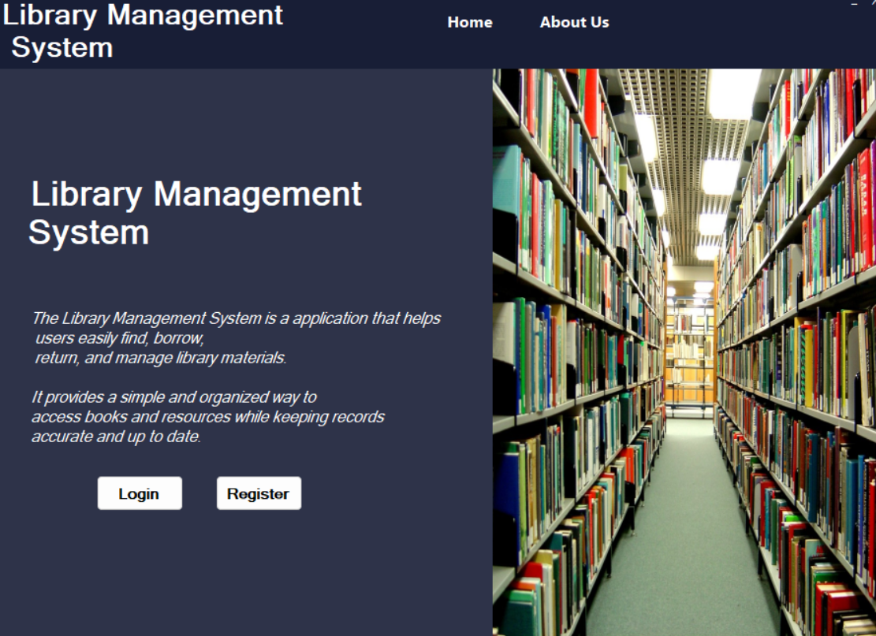

-Login Form
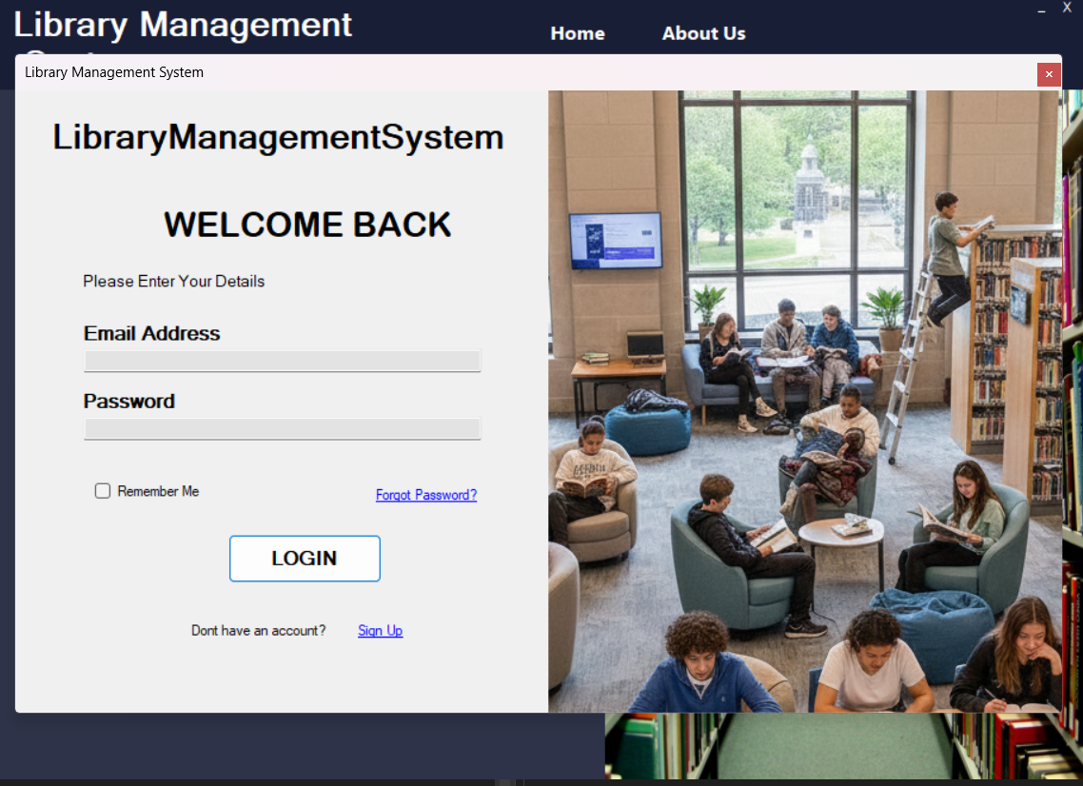

-Register Form
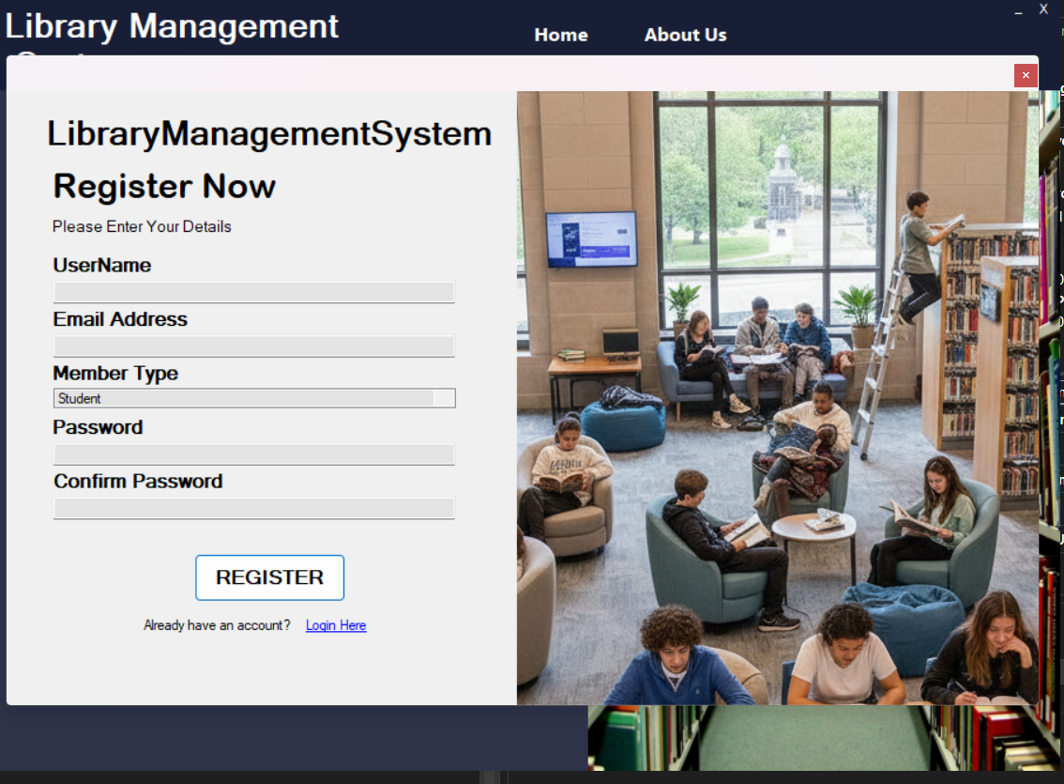
-Dashboard
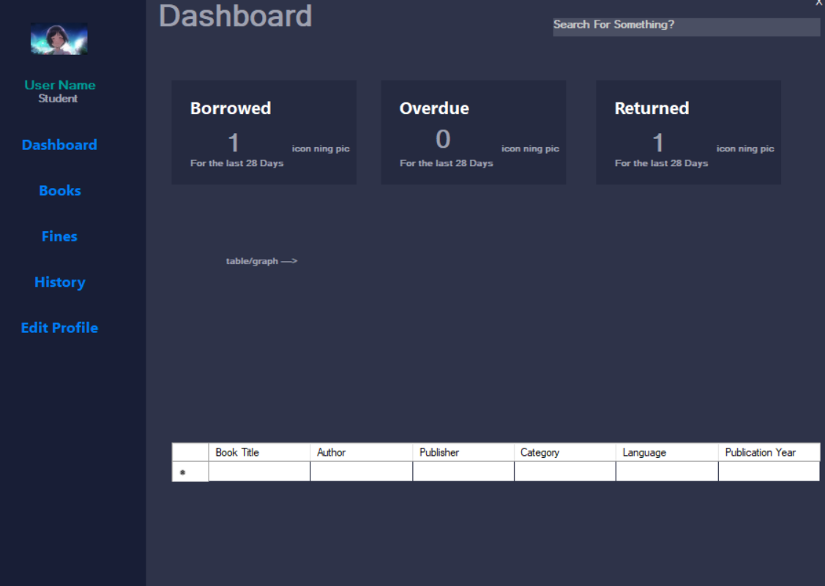

-Books
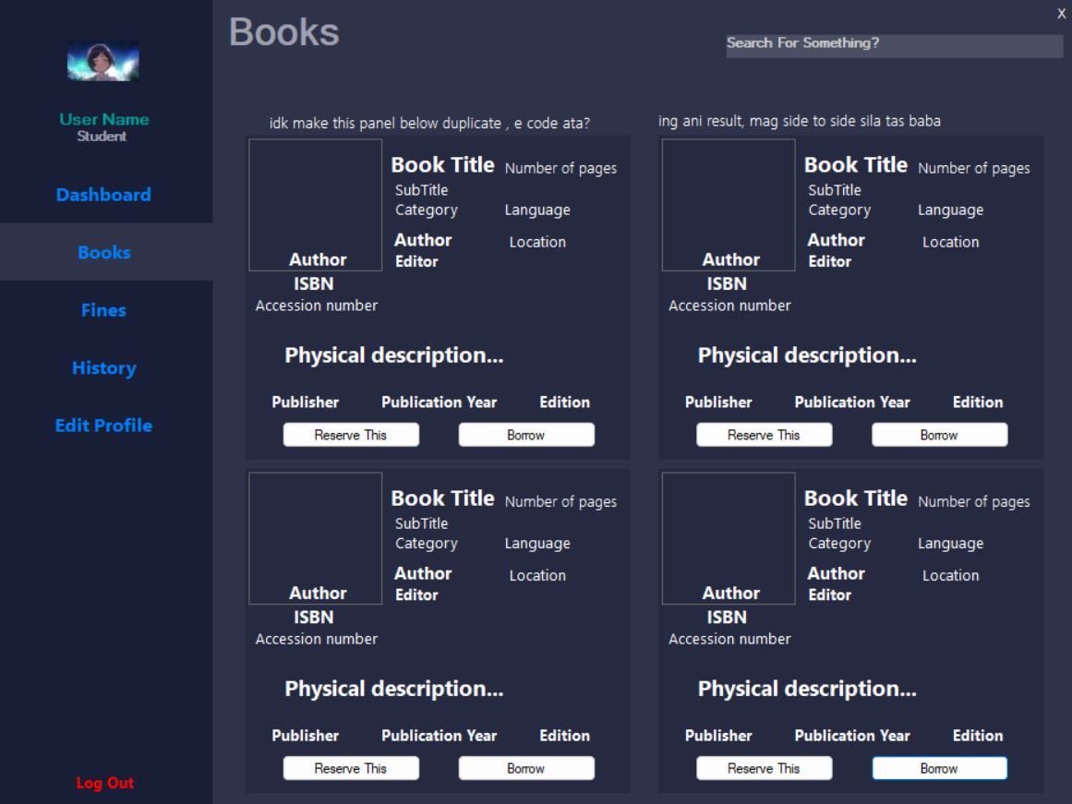
-Fines
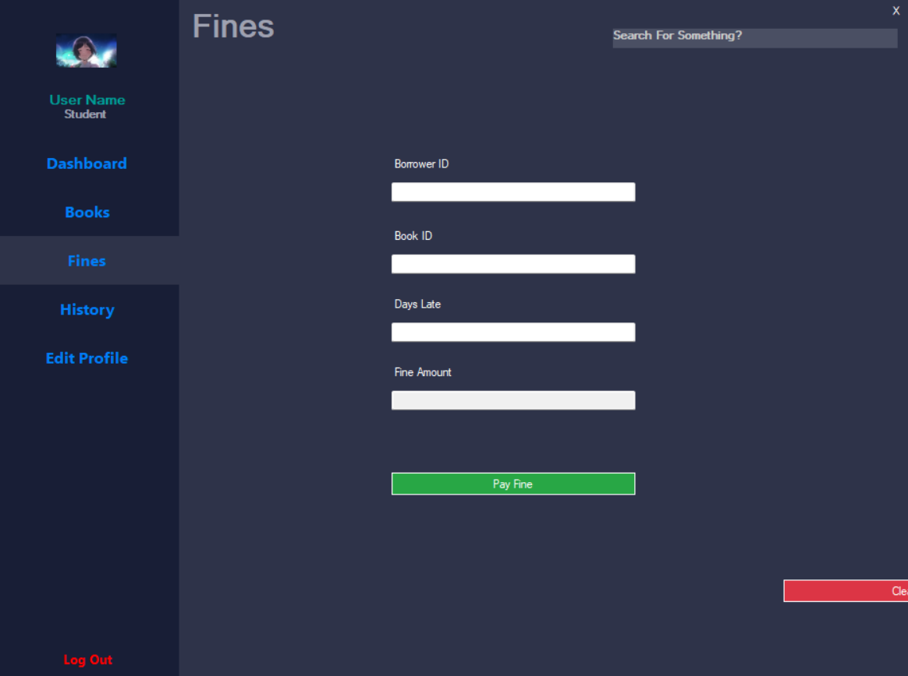

-History
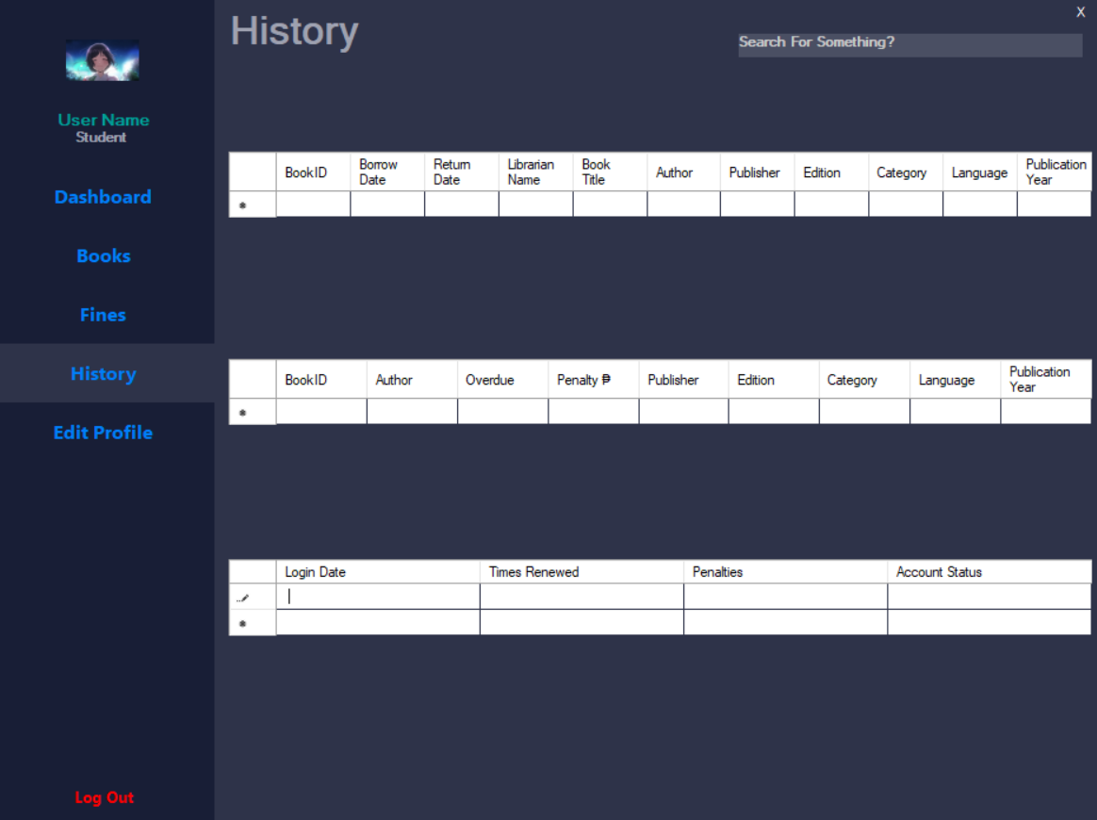
-Settings
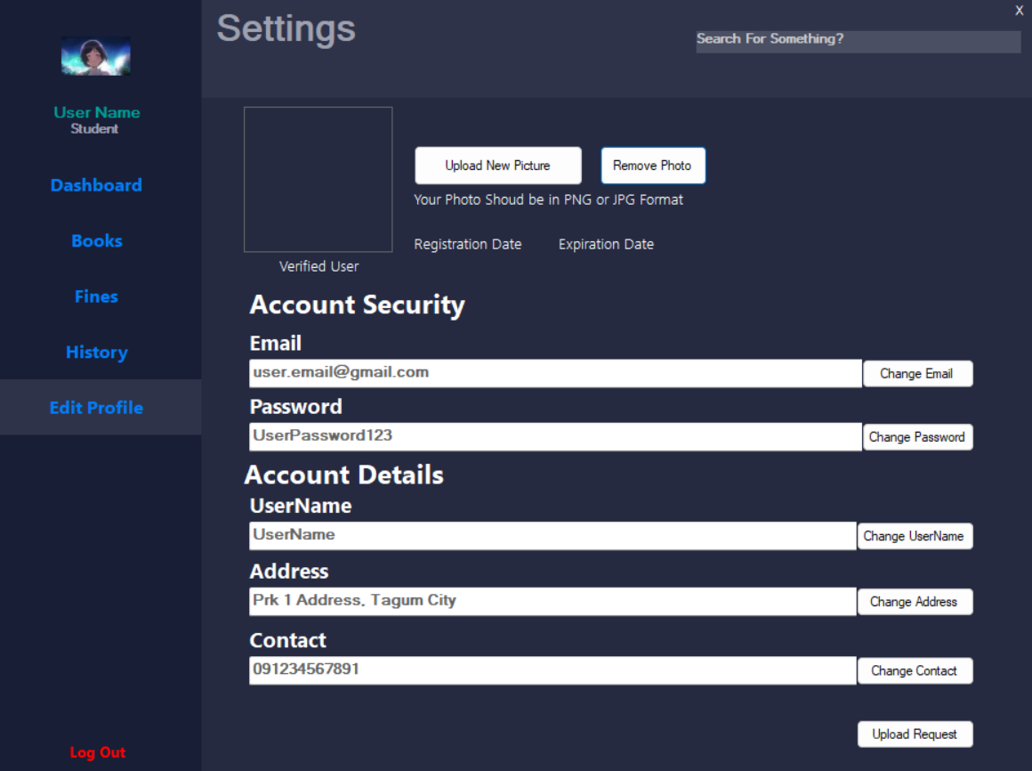

6. CONCLUSION
The Library Management System successfully meets its objectives by providing an efficient and user-friendly solution for managing library operations. It serves as a strong foundation for future enhancements.

